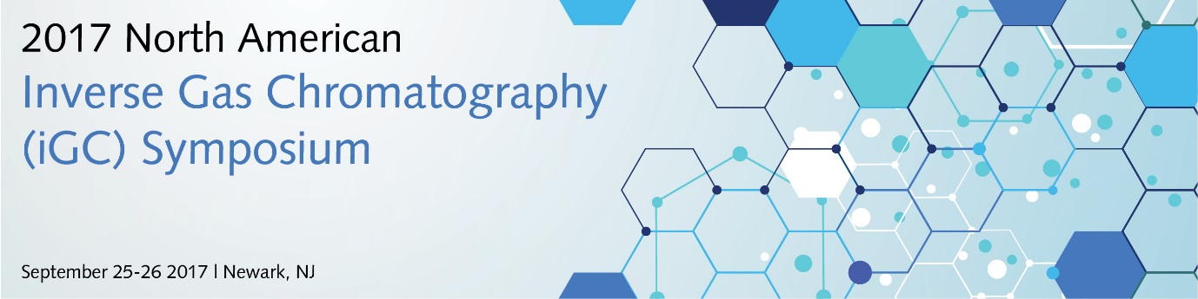

Please complete and submit the form to igc2017@surfacemeasurementsystems.com

Personal Information:
Name: |  |  |  | Date:
Organization:
Address 1:

Address 2:
City: | State: |  | Postal/Zip code:
Email: |  | Phone no: |  |  | Fax no:
Please indicate if you required vegetarian food or any special meal:
Delegate Fee
Standard fee: $250 (Non-Student) $125 (Student)

After Sept. 8, 2017: $300 (Non-Student) $150 (Student)

On-site registration: $330 (Non-Student) $165 (Student)

Payment type: Credit Card Cheque BACS Cash (for on-site reg. only)

- Payment By BACS

Please remit to:
WITHIN USA: Bank of America, Account # 4439 005900, Routing #031 202 084
OUTSIDE USA: Bank of America, Account # 4439 005900, Routing #0260-0959-3
Note: Please indicate as reference “IGC Symposium –[delegates name]
- Payment By Check

Please send to the address below:

iGC2017
Surface Measurement Systems NA
2125 28th Street SW, Suite 1, Allentown, PA 18103

- Payment By Credit Card:
Name on Card:
Address 1:
Address 2:
City: | State: |  | Postal/Zip code:
Total Amount:
Credit Card Number:
Visa MC AMEX |  | CVV  (4-digit number for Amex) |  | Exp. Date:
Cancellation Policy: If you notify the Organizer of your cancellation up to two weeks prior to the event, we will provide a full refund.

For program inquiries, please contact:
Ron Gray: (Email) rgray@surfacemeasurementsystems.com (Tel no): +1 610-798-8299

For payment inquiries, please contact:
Andrea Gimbar: (Email) agimbar@surfacemeasurementsystems.com (Tel no): +1 610-798-8299

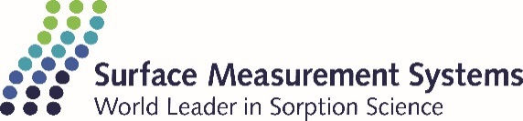

Surface Measurement Systems Ltd.
Unit 5, Wharfside, Rosemont Road, Alperton, London.
HA0 4PE | Tel no: +44 (0) 208 795 9400
Surface Measurement Systems NA
2125 28th Street SW, Suite 1, Allentown, PA. 18103
Tel no: +1 610-798-8299

